

"ResumeLine.com"

A PROJECT REPORT SUBMITTED TO

# THE NATIONAL INSTITUTE OF ENGINEERING, MYSURU

(An Autonomous Institute under VTU, Belagavi)

In partial fulfillment of the requirements for Project work (Database Laboratory CS5L02), fifth semester

## Bachelor of Engineering in

**Computer Science and Engineering**

*Submitted by*

**Akarsh Kashyap (4NI20CS008)**

**Harendra (4NI20CS036)**

Under the Guidance of

Dr. Annapurna V K Professor

Poornima N Assistant Professor

Amitha S Assistant Professor





## DEPARTMENT OF COMPUTER SCIENCE AND ENGINEERING

2022-2023

**DEPARTMENT OF COMPUTER SCIENCE AND ENGINEERING**

# THE NATIONAL INSTITUTE OF ENGINEERING



***CERTIFICATE***

This is to certify that the project work entitled “**ResumeLine.com**” is a work carried out by **Akarsh Kashyap (4NI20CS008) , Harendra (4NI20CS036)** in partial fulfillment for the project work (Database Laboratory – CS5L02), fifth semester, Computer Science & Engineering, The National Institute of Engineering **(**Autonomous Institution under Visvesvaraya Technological University, Belagavi) during the academic year 2022-2023. It is certified that all corrections and suggestions indicated for the Internal Assessment have been incorporated in the report deposited in the department library. The project work report has been approved in partial fulfillment as per academic regulations of The National Institute of Engineering, Mysuru.

### Signature of the Internal Guides Signature of the HoD

**_**

Dr. Annapurna V K Professor

Poornima N Assistant Professor

Amitha S Assistant Professor

Dr. Yuvaraju B.N Professor and Head Dept. of CS&E NIE, Mysuru

### Signature of the Examiners with date

Name: Designation:



Name: Designation:



# Acknowledgements

We would like to take this opportunity to express our profound gratitude to all those people who were directly or indirectly involved in the completion of this project. We have a great pleasure in expressing our deep sense of gratitude to our principal **Dr. Rohini Nagapadma** (Principal and Professor) for having provided us with a great infrastructure and well-furnished labs and providing us an opportunity to carry out our project work.

We would also like to extend our sincere gratitude to **Dr. Yuvaraju B.N**, our H.O.D for being a source of inspiration and instilling an enthusiastic spirit in us throughout the process of project making. We are grateful to our guides **Dr. Annapurna V K** (Professor, Dept. of CS&E), **Poornima N** (Assistant professor, Dept. of CS&E) and **Amitha S** (Assistant professor, Dept. of CS&E), The National Institute of Engineering for their unfailing encouragement and suggestion given to us during our project work.

We would like to extend our special thanks to **Narender M** (Assistant Professor, Dept. of CS&E) for his support in clarifying doubts and encouragement.

We are thankful to our parents, family and friends for their constant support, inspiration, and encouragement without which we would not have come so far. We thank each one who encouraged us in every possible way.

### -Akarsh Kashyap

### -Harendra

**Table of Contents**



Chapter 1 ......................................................................................................................................................1

**1.1 Abstract**:.................................................................................................................................................1

**1.2 Objective**:................................................................................................................................................2

**1.3 Functionalities** : .....................................................................................................................................2

**1.4 Benefits** : ................................................................................................................................................2

Chapter 2 ......................................................................................................................................................3

**2.1 Existing System**:....................................................................................................................................3

**2.2 Proposed System**:..................................................................................................................................4

**2.3 System Requirements**:..........................................................................................................................5

Chapter 3 ......................................................................................................................................................6

**3.1 System Architecture**..............................................................................................................................6

**3.2 ER Diagram**..........................................................................................................................................11

Chapter 4 ....................................................................................................................................................11

**4.1 Implementation:**..................................................................................................................................13

**4.2 Tools Used For Implementation :**.....................................................................................................15

Chapter 5 ....................................................................................................................................................17

**5.1 Design Of Test Cases :**........................................................................................................................17

**5.2 Sample Test Cases :**............................................................................................................................19

Chapter 6 ...................................................................................................................................................19

**Home Page:** .............................................................................................................................................20

**Login/Signup Pages:** ..............................................................................................................................20

**Successful Login:**.....................................................................................................................................21

**Apply Page:** .............................................................................................................................................22

**Apply Form Page:** ..................................................................................................................................22

**Post Page:**................................................................................................................................................23

**View Applicants Page:**............................................................................................................................23

**Conclusions And Future Enhancements**...............................................................................................24

**References:**...............................................................................................................................................24



**TABLES**

**Chapter 3**

Table 3.1………………………………………………………………………………………9

Table 3.2………………………………………………………………………………………9

Table 3.3……………………………………………………………………………………..10

Table 3.4 ………………………………………………………………………………….…10

**FIGURES**

**Chapter 3**

Fig 3.5………………………………………………………………………………………..11

**Chapter 4**

Fig 4.1…………………………………………………………………………………….…14

**Chapter 6**

Fig 6.1………………………………………………………………………………………20

Fig 6.2………………………………………………………………………………………20

Fig 6.3………………………………………………………………………………………21

Fig 6.4………………………………………………………………………………………21

Fig 6.5………………………………………………………………………………………22

Fig 6.6………………………………………………………………………………………22

Fig 6.7………………………………………………………………………………………23

Fig 6.8………………………………………………………………………………………23



**CHAPTER 1**

# Introduction

## Abstract

The purpose of ResumeLine.com is to automate the existing manual system by the help of computerized equipment’s and full-fledged computer software, fulfilling their requirements, so that their data/information can be stored for a longer period with easy accessing and manipulation of same. The required software and hardware are easily available and easy to work with.

ResumeLine.com , as described above can cause error free, secure, reliable, and fast filtering system. It can assist the user to consider other activities rather than record keeping. Thus, it will help organization in better utilization of resources. The organization can maintain computerized records without redundant entries. Basically, the project describes how to manage for good performance and provide better services for the clients.

It provides recruiter with list of resumes that are already filtered. Students also get a one stop platform for all the jobs. Recruiter with just one click gets the list of resumes and can select a number of students by sending automatic E-mails in just one click. This ensures a fast , reliable and secure way of recruiting. Thus, saving a lot of time of both students as well as recruiters.



## Objective

The main objective of the project on ResumeLine.com is to make recruitment process simpler and faster. The purpose of the project is to build an application program to reduce the manual work for filtering applied resumes. It tracks all the details about the candidate’s skills.

## Functionalities Provided By ResumeLine.com Are As Follows

* + - Auto E-mailing system.
    - Checking of last application date and validating candidates.
    - End to end student, recruiter communication.
    - Highly interactive platform.
    - Takes institute, coding platforms, grades, skills into consideration.

## Benefits

* + - Provide fast and efficient service.
    - Provides opportunities.
    - Checks the skillset.
    - Easy selection process.
    - Increases recruiter and student satisfaction.



# Chapter 2

**System Analysis**

# 2.1 Existing System

* + - Students have to wait a long time after application.
    - Everything is done manually like going through all the resumes and then inviting the desired candidates.
    - Mass recruitment would take a lot of time.

## Drawbacks Of Existing System:

* + - Lack of security of data.
    - More manpower.
    - Time consuming.
    - Non satisfactory student feedback.
    - Does not provide the feature of mailing to those students

who are not selected and on what criteria they were rejected.



# 2.2 Proposed System

Every recruiter has their own expectation from a candidate according to company’s requirements. Going through all the resumes that have been submitted for a particular role can be time consuming and irritating for a recruiter if he decides to do it all by himself. This project ease the work of recruiter. It first stores all the skillsets that a recruiter is looking for and uses them as keywords to search through resumes. According to the search result it then ranks resumes and present it to the recruiter. During search it goes word by word in a resume and checks for matching skillset, then according to the maximum number of skillsets found it is ranked.

## Advantages of proposed system:

* + - Security of data.
    - Ensure data accuracy.
    - Minimize manual data entry.
    - Minimum time needed for various processing.
    - Greater efficiency.
    - Better service.
    - User friendly and interactive.



## 2.3 System Requirements

* + - System needs to store the information about every student.
    - System needs to store the information about every recruiter.
    - System needs to keep the record of posted jobs.
    - System needs to keep the record of jobs applied for.
    - System also needs a search area.

## Software Requirement:

* Apache Server 2.0 or above.
* XAMPP v3.3.0.
* PHP version 5.3 or above
* MySQL Version 5.5 or above
* Latest browser: Chrome, Firefox, Safari etc.

## Hardware Requirements:

* Processor Pentium IV or higher version.
* RAM 128Mb or above.
* Operating system like Windows/Linux.
* 1920 x 1080p monitor for better viewing experience.

## Other Requirements:

* Fast and high bandwidth internet connection.



# Chapter 3

**System Design**

## System Architecture:

**Input Design**: The system has four sections:

1. Apply section.
2. Post section.
3. Student section.
4. Recruiter section.

### Student Section:

* + Student has dedicated login and signup page.
  + Initially the Student has to sign-up using his user name, email, gender role and set a password.
  + After signup, the User has to login and can apply for any job he/she wants.
  + Student then gets a mail whether he/she is selected or not.
  + If selected then the student gets a proper interview/coding round link in his/her provided mail.
  + If not selected then the student gets a mail specifying the criteria on why he/she was rejected and what he/she needs to improve upon.



### Recruiter Section:

* + The website has a dedicated login/signup for each recruiter.
  + After login, the recruiter gets to see the total number of applicants for a particular job.
  + Recruiter can post multiple job vacancies.
  + Recruiter can filter the resumes in one click and can invite the desired students through mail.

### Apply Section:

* + This section contains the list of jobs to be applied for, with the job id.
  + Students can access this section and can apply for any suitable job.

### Post Section:

* + In this section the recruiter post the jobs with the job id , company name , job role and description of the job.
  + Apply section use this section to show the available jobs to the students.



### Database Design:

The data in the system has to be stored and retrieved from database. Designing the database is part of system design. Data elements and data structures to be stored have been identified at analysis stage. They are structured and put together to design the data storage and retrieval system.

A database is a collection of interrelated data stored with minimum redundancy to serve many users quickly and efficiently. The general objective is to make database access easy, quick, inexpensive and flexible for the user. Relationships are established between the data items and unnecessary data items are removed.

Normalization is done to get an internal consistency of data and to have minimum redundancy and maximum stability. This ensures minimizing data storage required, minimizing chances of data inconsistencies and optimizing for updates.



### Table Design:

1. **Student Table** : This table is used to store necessary details like Email-id (primary key), password, first name, last name, gender of the students which is further used in the website. The passwords are stored thus providing good security for the student data.

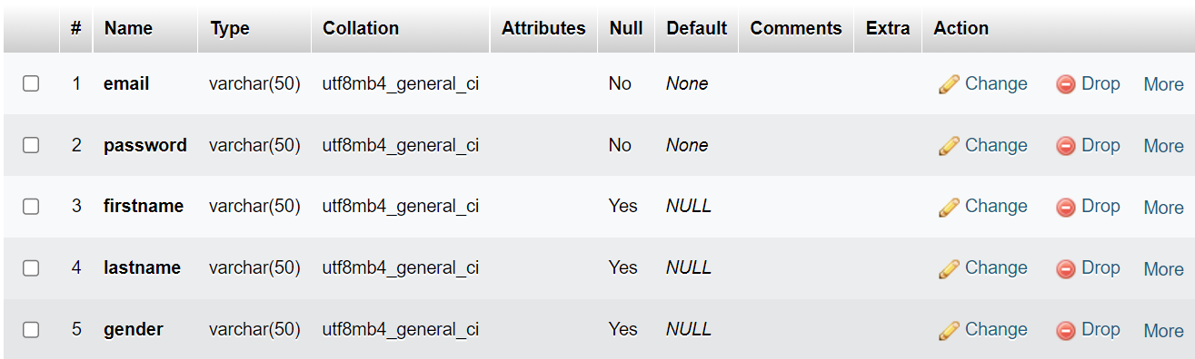

*Table 3.1*

1. **Recruiter Table** : This table is used to store necessary details like Email-id (primary key), password, first name, last name, gender of the students which is further used in the website. The passwords are stored thus providing good security for the recruiter data.

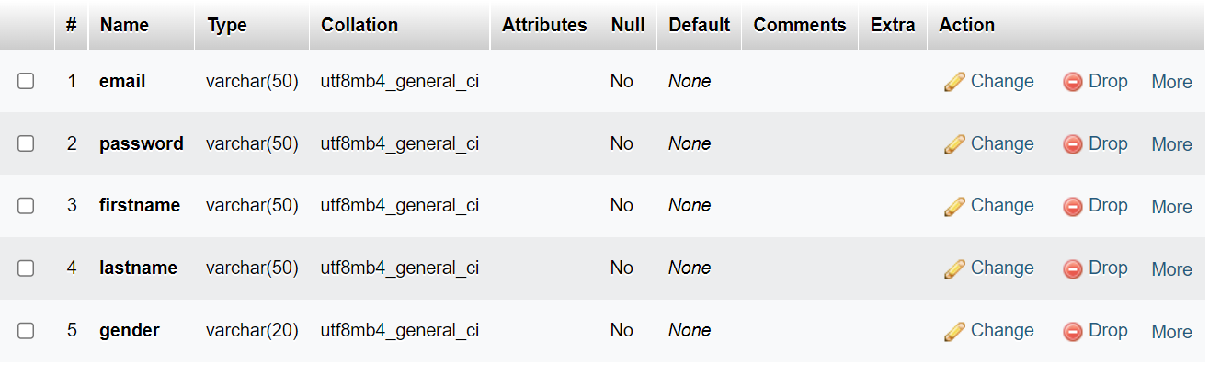

*Table 3.2*



1. **Apply table** :This table stores the details of the jobs which are applied by students. It also contains Id, first name, last name, institute, CGPA, Codeforces rating, Codechef rating, kickstart rank, skillset and finally resume in pdf format.

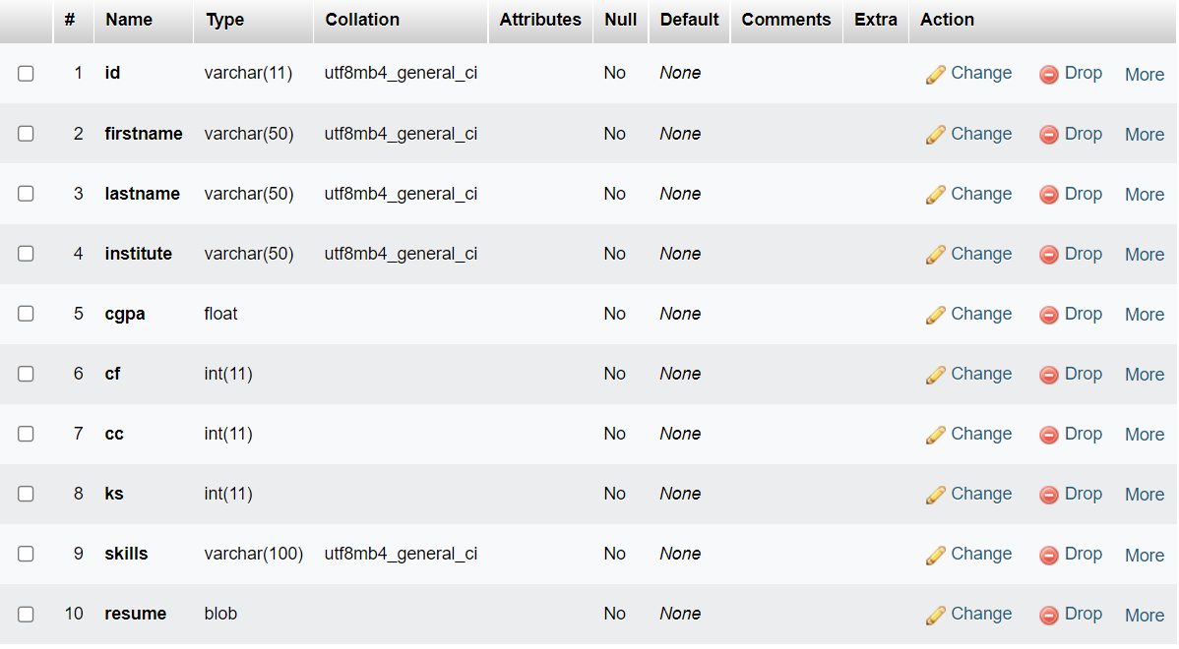

*Table 3.3*

1. **Post Table** : This table stores the details of the jobs which are posted by recruiters. It also contains recruiter mail (primary key), job id, role, description and company name.

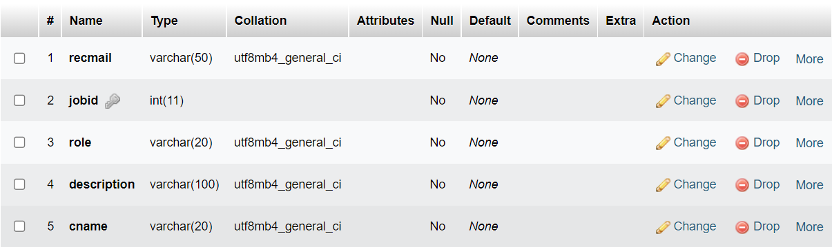

*Table 3.4*



# ER Diagram:

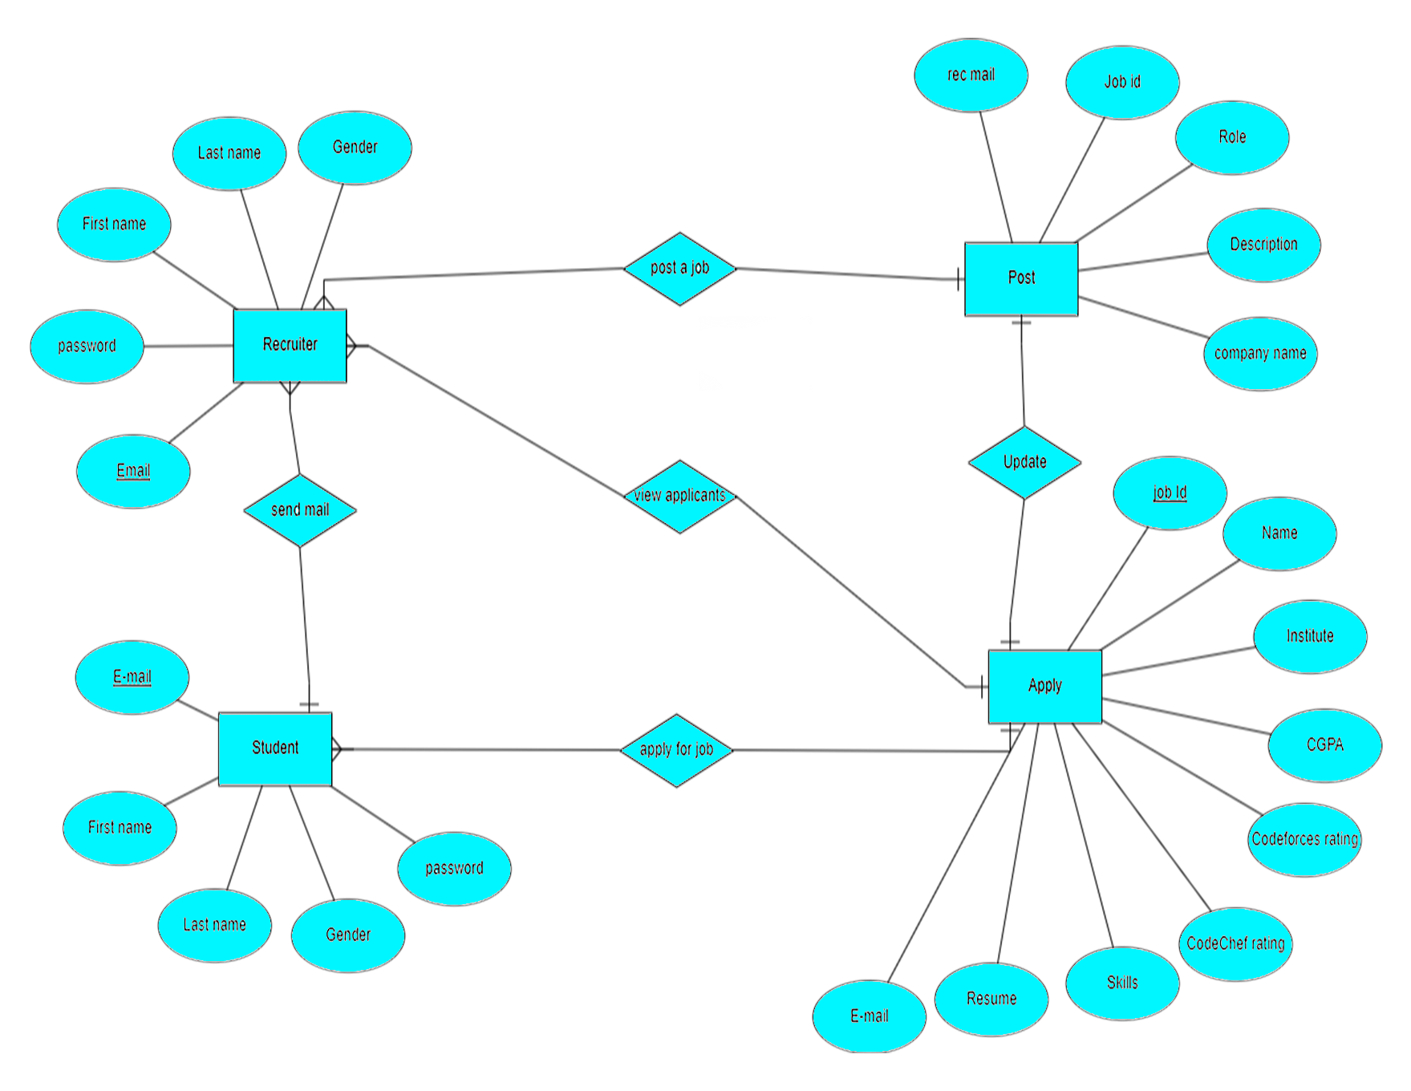

*figure 3.5*

This is the ER diagram for the ResumeLine.com. We have four tables namely apply, post, recruiter and student. Each table has its own attributes which is specified in figure.



**Student Entity :** This entity is used to store necessary details like Email-id (primary key), password, first name, last name, gender of the students which is further used in the website. The passwords are stored thus providing good security for the student data. This entity can access the apply entity, so it is link to apply entity.

**Recruiter Entity :** This entity is used to store necessary details like Email-id (primary key), password, first name, last name, gender of the students which is further used in the website. The passwords are stored thus providing good security for the recruiter data.

**Apply Entity :** This entity stores the details of the jobs which are applied by students. It also contains Id, first name, last name, institute, CGPA, Codeforces rating, Codechef rating, kickstart rank, skillset and finally resume in pdf format.

**Post Entity :** This entity stores the details of the jobs which are posted by recruiters. It also contains recruiter mail (primary key), job id, role, description and company name. The post entity is accessible by the recruiter only. He/She can add job or close a job which was posted earlier , if the recruitment is already finished.



# Chapter 4

**System Implementation**

## Overview Of System Implementation:

This system, “ResumeLine.com” has been developed using XAMPP SQL server, which provides the database support, PHP for back-end support along with HTML, CSS, JavaScript for the front-end development.

**Database:** The core of our project is the database, which is implemented using MySQL. It is an open-source relational database management system. With the help of MySQL concepts like DDL (Data Definition Language), and DML (Data Manipulation Language) we have implemented the resumeline.com database. The database contains different tables like apply, post, student, recruiter. The relational database systems usually consist of three levels namely, External level, Conceptual level, and internal level.

**External Level:** It is also called “view level” because several users can view their desired data from this level which is internally fetched from database with the help of conceptual and internal level mapping. The user doesn’t need to know the database schema details such as data structure, table definition etc. user is only concerned about data which is returned to the view level after it has been fetched from database (present at the internal level) thus providing effective abstraction. External level is the “top level” of the three level DBMS architecture.

**Conceptual Level:** It is also called “logical level”. The whole design of the database such as relationship among data, schema of data etc. are described in this level. Database constraints and security are also implemented in this level of architecture. This level is maintained by DBA (database administrator). This level is not accessed by the end user, and he/she does not need to understand the functionalities from this level.

**Internal Level:** This level is also known as physical level. This level describes how the data is stored in the storage devices. This level is also responsible for allocating space to the data. This is the lowest level of the three-tier DBMS architecture.

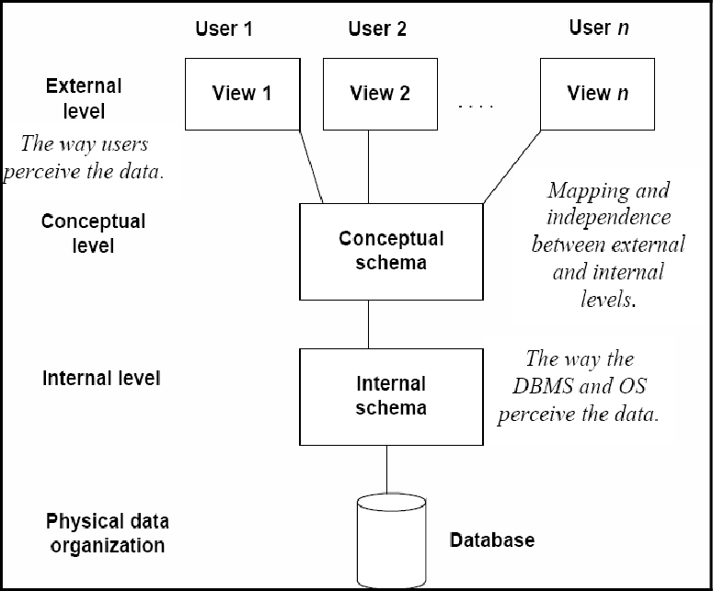

*Figure 4*

**In The Above Diagram :**



* It shows the DBMS architecture.
* Mapping is used to transform the request and response between various database levels of architecture.
* Mapping is not good for small DBMS because it takes more time.
* In External / Conceptual mapping, it is necessary to transform the request from external level to conceptual schema.
* In Conceptual / Internal mapping, DBMS transform the request from the conceptual to internal level.



## Tools used for Implementation:

1. **PHP:** Stands for Hypertext Preprocessor. PHP is a server-side scripting language that is embedded in HTML. It is used to manage dynamic content, databases, session tracking, even build entire e-commerce sites. It is integrated with a number of popular databases, including MySQL, PostgreSQL, Oracle, Sybase, Informix, and Microsoft SQL Server.

Features of PHP include, PHP can –

* + Generate dynamic page content.
  + Create, open, read, write, delete, and close files on the server.
  + collect form data.
  + Send and receive cookies.
  + Add, delete, and modify data in your database.
  + Be used to control user-access.
  + Encrypt data.

1. **Hyper Text Markup Language (HTML):** Hypertext Markup Language (HTML) is the standard markup language for creating web pages and web applications. With Cascading Style Sheets (CSS) and JavaScript, it forms a triad of cornerstone technologies for the World Wide Web. Web browsers receive HTML documents from a web server or from local storage and render the documents into multimedia web pages. HTML describes the structure of a web page semantically and originally included cues for the appearance of the document.

HTML elements are the building blocks of HTML pages. With HTML constructs, images, and other objects such as interactive forms may be embedded into the rendered page. HTML provides a means to create structured documents by denoting structural semantics for text such as headings, paragraphs, lists, links, quotes, and other items.

1. **Cascading Stylesheets (CSS):** Cascading Style Sheets (CSS) is a style sheet language used for describing the presentation of a document written in a markup language like HTML. CSS is a cornerstone technology of the World Wide Web, alongside HTML and JavaScript. CSS is designed to enable the separation of presentation and content, including layout, colors, and fonts. This separation can improve content accessibility.



1. **JavaScript:** JavaScript is a dynamic computer programming language. It is lightweight and commonly used as a part of web pages, whose implementations allow client-side script to interact with the user and make dynamic pages. It is an interpreted programming language with object- oriented capabilities. JavaScript is one of the three-core technologies of the world wide web content production. It is used to make web pages interactive and provide online programs, including video games. A majority of websites employ it, and all modern web programs support it without the need for plug-ins by means of built-in JavaScript engine.
2. **XAMPP:** XAMPP is one of the widely used cross-platform web servers, which helps developers to create and test their programs on a local webserver. It was developed by the Apache Friends, and its native source code can be revised or modified by the audience.

It consists of Apache HTTP Server, and interpreter for the different programming languages like PHP. XAMPP helps a local host or server to test its website and clients via computers and laptops before releasing it to the main server. It is a platform that furnishes a suitable environment to test and verify the working of projects based on Apache, MySQL database, and PHP through the system of the host itself.

# Chapter 5

* 1. **Design of Test Cases**

# System Testing



Testing is the major process involved in software quality assurance and represents the ultimate review of specification, design and coding. The overall objective of testing is to find the maximum number of errors with minimum efforts. Here test data is prepared and is used to test the modules individually. System testing makes sure that all components of the system function properly as a unit by actually forcing the system to fail.

The test cases should be planned before testing begins. Then as the testing progresses, testing shifts focus in an attempt to find errors in integrated clusters of modules and in the entire system. The philosophy behind testing is to find errors in integrated clusters of modules and in the entire system. The philosophy behind testing is to find errors. Actually, testing is the estate of implementation that is aimed at ensuring that the system works actually and efficiently before implementation.

The Testing phase involves the testing of individual program units and the functionality with various test data. Preparation of the test data plays a vital role in system testing. After preparing the test data the system under study was tested using those test data. A series of tests were performed on the developed system before implementing the same.

The various types of testing done on system were

* + - Unit Testing
    - Integration Testing
    - Validation Testing
    - Acceptance Testing

### Unit Testing

Unit Testing is a procedure used to validate that a particular module of source code is working properly. The procedure is to write test cases for all functions and methods so that whenever a change causes a regression, it can be quickly identified and fixed.



Ideally, each test case is separate from the others. This type of testing is mostly done by the developers and not by end-users. The goal of unit testing is to isolate each part of the program and show that the individual parts are correct. Unit testing provides a strict, written contract that the piece of code must satisfy.

### Integration Testing

Integration testing is the phase of software testing in which individual software modules are combined and tested as a group. It follows unit testing and precedes system testing. Integration testing takes as its input modules that have been checked out by unit testing, groups them in larger aggregates, applies tests defined in an integration test plan to those aggregates and delivers as its output the integrated system ready for system testing.

### Validation Testing

At the culmination of integration testing, software is completely assembled as a package, interfacing errors have been uncovered and corrected, and a final series of software tests, validation testing was carried out.

Validation testing can be defined in many ways, but a simple definition is that validation succeeds when the software functions in a manner that can be reasonably expected by the customer/user.

### Acceptance Testing

When that user fined no major problems with its accuracy, the system passers through a final acceptance test. This test confirms that the system needs the original goals, objectives and requirements established during analysis without actual execution which elimination wastage of time and money acceptance tests on the shoulders of users and management, it is finally acceptable and ready for the operation.



* 1. **Sample Test Cases**

A test case in a software engineering is a set of conditions or variables under which a tester will determine whether an application or software system is working correctly or not. Testing is the major process involved in software quality assurance and represents the ultimate review of specification, design and coding. The overall objective of testing is to find the maximum number of errors with minimum efforts. Here test data is prepared and is used to test the modules individually. System testing makes sure that all components of the system function properly as a unit by actually forcing the system to fail.

The mechanism for determining whether a software program or system has passed or failed such a test is known as a test case. Test cases often referred to as test scripts, particularly when written. Written test cases are usually collected into test suites. The Testing phase involves the testing of individual program units and the functionality with various test data. Preparation of the test data plays a vital role in system testing. After preparing the test data the system under study was tested using those test data. A series of tests were performed on the developed system before implementing the same.

|  |  |
| --- | --- |
| **Input field label** | **Constraint and message displayed during error** |
| If any field is submitted as empty in customer login page. | Message, please fill the fields is displayed according to each label. |
| If username or password given do not match with database values during log-in. | Message saying entered invalid email or password. |
| During sign-up if student/recruiter gives password of length less than 8 characters. | Message to enter text of length 8 character or more. |
| If user enters username of length less than  5 characters. | Message to enter text of length 5 characters or  more. |
| Verification of Admin login – If admin enters wrong email or password. | Pops up a message as entered wrong email or password. |

# Chapter 6

**Results**

## Home page:

The first web page of the website is as follows. It gives option to user to login, if user account exists and sign- up option for new user.

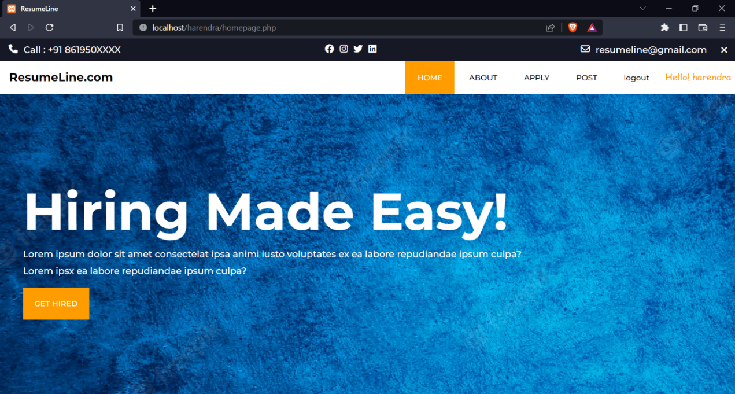

## Sign up:

*Figure 6. 1*

Sign up is where customer register if account does not exist. The customer register depending on roles like student, faculty staff, professor etc. and by entering all details in prescribed fields.



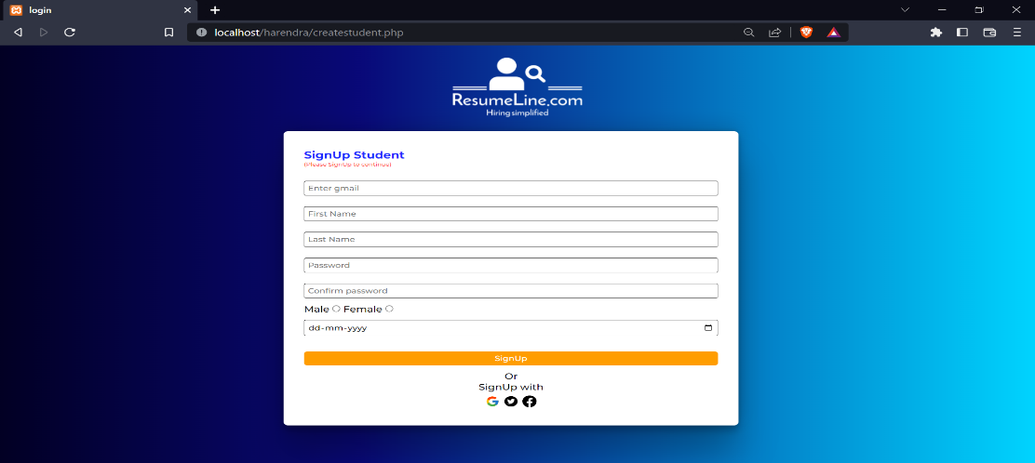

*Figure 6. 2*



After successful login, it displays the following message for customer.



*Figure 6. 3*

All the tables are listed below.

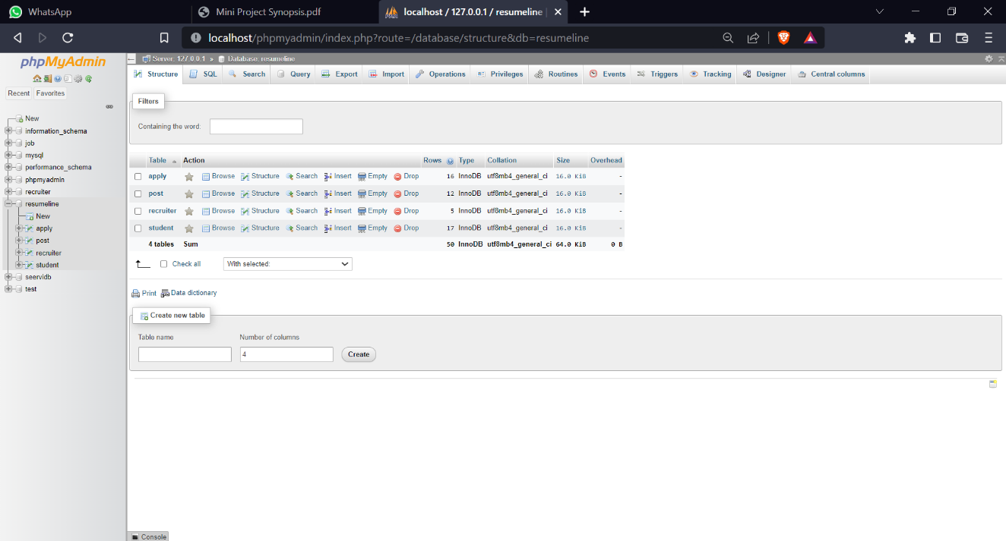

*Figure 6. 4*



## APPLY : After click on apply button by the student the following page comes up.

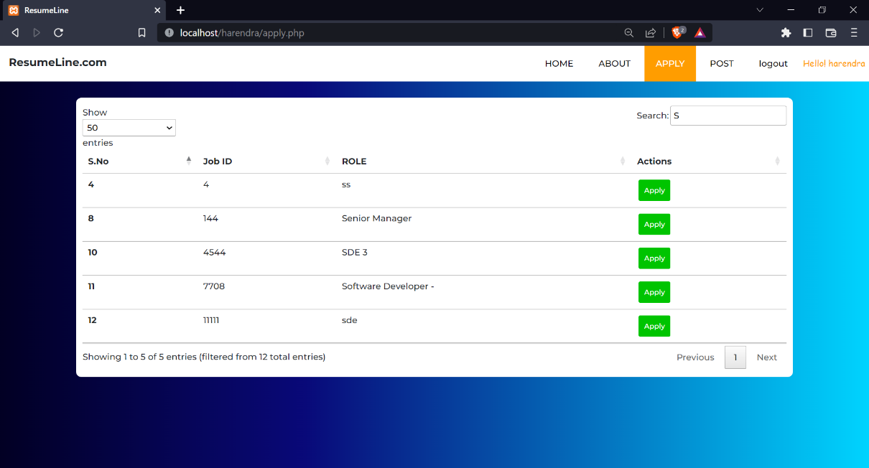

*Figure 6. 5*

Clicking on apply for a particular job, this form comes up.

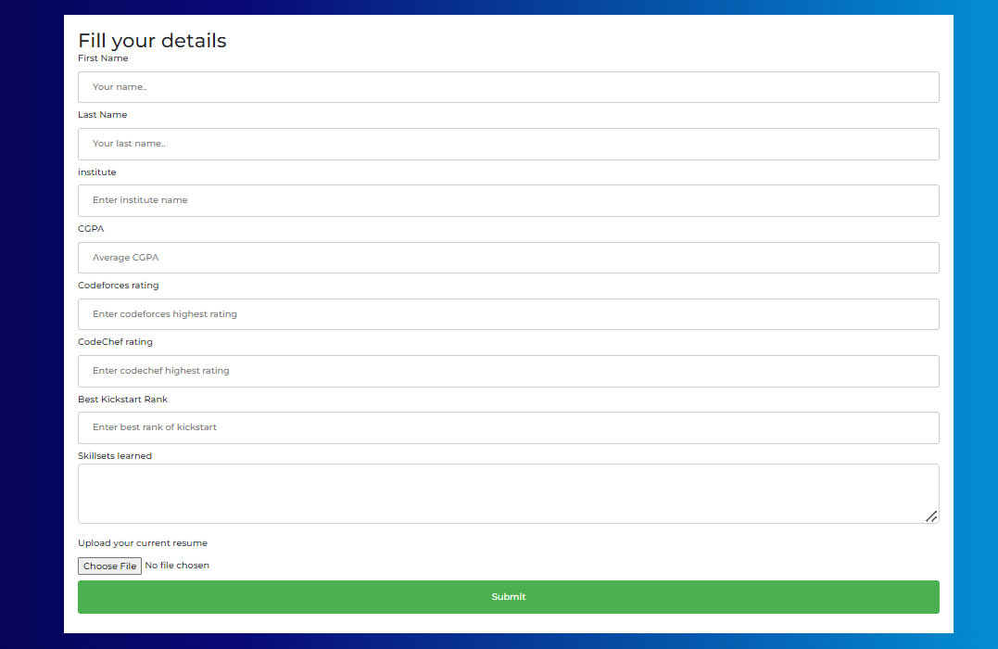

*Figure 6. 6*



## Post page: This is the post job page for the recruiter. View button shows all the applicants for the job and remove button drops a job which was posted earlier.

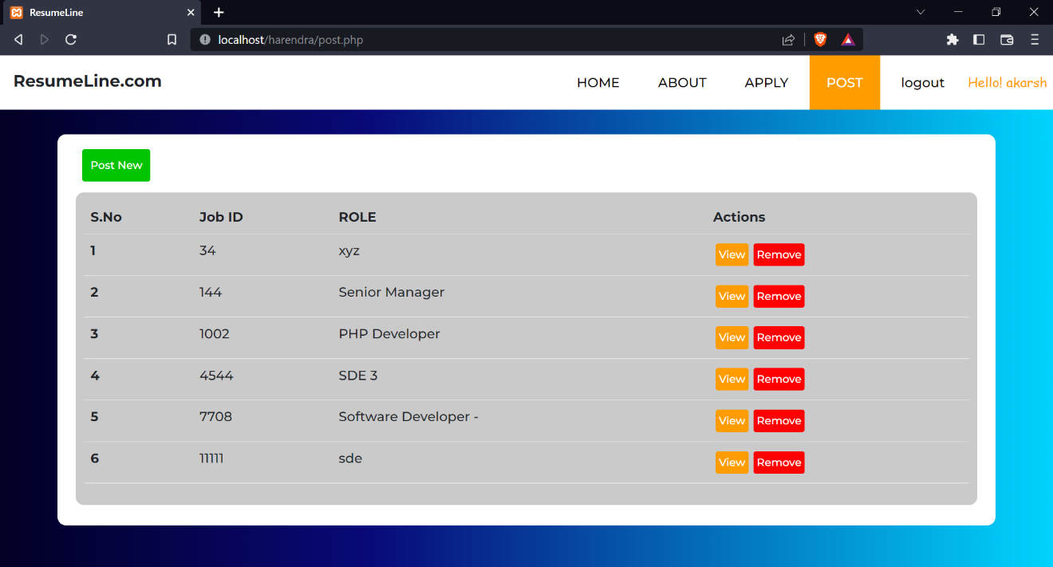

*Figure 6. 7*

## View applicants: After clicking view button this comes up. Here recruiter can filter according to requirements.

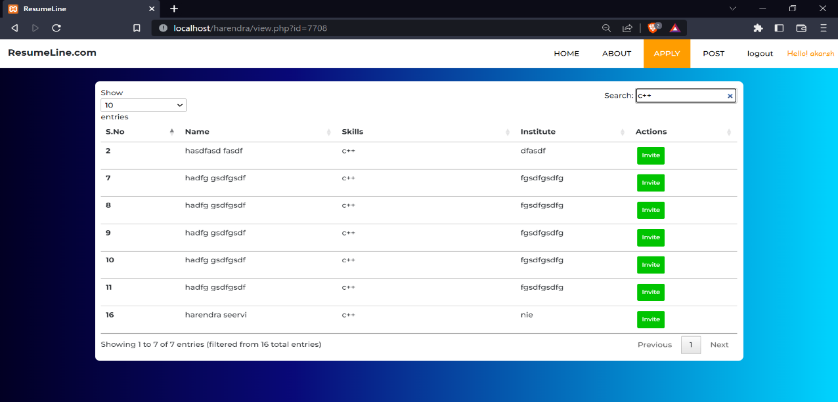

*Figure 6. 8*

After clicking on invite it sends automatic e-mail to the selected candidates.



## Conclusion and future enhancement

**Conclusion**

This project proved to be a very interesting and challenge for us, and we are glad about the way this system turned out. This website is simple and functional.

The goal of our project is to reduce the time it takes for filtering the resumes. This website enables the recruiter to post jobs and in no time filter the bulk of applicant resumes. This website also helps the students to get info about all the available jobs at one place, they don’t have to surf the whole internet to search for a suitable job opportunity. ResumLine.com is a software application that can make it easier to manage applicants for a particular job.

## Future enhancement:

* Allows recruiter to give feedback about student’s resume.
* AI can be used to scan the resume and filter them, which makes it even more faster.
* Adding a direct coding portal would lead the selected student to coding round directly.
* It can be made a paid platform for the recruiters.

## References

Beginnersbook.com - https://beginnersbook.com/2018/11/dbms-three-level-architecture/

CSS Documentation - https://developer.mozilla.org/en-US/docs/Web/CSS

HTML Documentation - https://developer.mozilla.org/en-US/docs/Web/HTML

W3Schools - https://[www.w3schools.com/](http://www.w3schools.com/)

JavaScript Docs - https://[www.tutorialspoint.com/javascript/javascript_overview.htm](http://www.tutorialspoint.com/javascript/javascript_overview.htm)

XAMPP Documentation - https://[www.javatpoint.com/xampp](http://www.javatpoint.com/xampp)